**Case Study – Impact of Canada Post Union Workers Strike on Parcel Volumes**

Conducted by:

Boris Garbuzov

Customer:

Canada Post

Toronto, Canada

2020

**PROBLEM SETTING**

· For this case study you will be given a business question and a dataset and are asked to perform all steps in the analytical process.

· You may use any software to manipulate the data. Keep a record of the steps you took, either in form of code (with comments) or a task list. This documentation should be separate from the final report you prepare.

· Keep a record of your logic for any decisions you made in situations where there is more than one valid option.

· You are encouraged to go beyond what is explicitly required if it aligns with the overall purpose of the analysis.

· Prepare a presentation or report that:

* + Highlights irregularities in data and how you addressed them
  + Clearly presents relevant descriptive statistics
  + Outlines the objectives of the study in your own words
  + Includes the results of any analysis you perform to answer the business question
  + Optional: Include any next steps or recommendations you wish to offer

**Business Context:**

In late 2018, the Canadian Union of Postal Workers (CUPW) went on strike. Unfortunately, the strike fell during the busiest time of year for Canada Post, referred to as “Peak Season”. The strike affected Canada Post’s profitability and fractured relationships with some of our customers – businesses who rely on Canada Post to deliver their products. There are two reasons for the effects on Canada Post’s profitability: 1) Canada Post was not able to operate at full capacity and 2) some customers took some or all of their business elsewhere (e.g. FedEx or UPS).

The marketing department has data on parcel volumes for the previous and current years, and would like to understand the impact on Canada Post’s volumes across the three customer groups: small, medium and large customers.

**Additional business questions:**

· How much parcel business (volume) was lost because of the strike, overall and by customer group?

· Which customer group recovered the fastest and slowest?

· Have we fully recovered from the impact of the strike?

· Do rumours of a potential strike have an impact even before the actual strike begins?

**Canada Post important dates:**

· Peak Season 2017: Nov 20, 2017 to Dec 3, 2018

· Peak Season 2018: November 5, 2018 to January 11, 2019

· Potential for strike first appears in media: September 12, 2018

· Union voted in favour of strike action: September 26, 2018

· Rotating Strikes began: October 22, 2018

· Back to work legislation took effect: November 27th

**Customer Groups:**

Small – Less than 10,000 parcels per year

Medium – 10,000 to 500,000 parcels per year

Large – Over 500,000 parcels per year

**Parcel volume data:**

Mock-up Data for Parcel volumes by week by customer provided in Excel.

1. **EXECUTIVE SUMMARY**

This report is requested by Canada Post HR department to select a candidate for the data scientist position. It is conducted within a week of time. The purpose of the investigation is to study the influence of strike in 2018 onto volume of CanadaPost operations, along with the associated events, including mass media messages.

The preliminary data visualization showed seasonal patterns. The trend factor was not analyzed, though is likely present as increasing. As a result of statistical tests, during the five weeks of strike period, the overall number of parcels decreased compared to the same period in 2017. However, this difference appears to be insignificant. After breakdown by customer group size, it appears that all three groups decreased their operations during the strike. However, this change is significant only for small customers.

When testing for after-strike recovery level, it was discovered that the volume was over-recovered (not only recovered but also increased) in all customer groups. It might be either due to overcompensation of the period constrained by strike limitations, or due to a permanent rising trend that we did not analyze.

Tests of influence of mass media revealed insignificant increase of activity after public announcement of the strike.

Further investigation can be conducted, applying the time series models. It would allow for break-point analysis and other advanced methods.

1. **DETAILED RESULT DEVELOPMENT**

Here we describe the steps of the results acquisition, from problem setting to data manipulation, and finally, to analysis of each question, posed in problem setting.

**2.1. Data pre-processing**

The data were provided in three Excel tables by years. The 2019 year was in long format, while 2018 and 2017 were in wide format. We also had to deal with other irregularities. One boundary week was duplicated in both 2017 and 2018 years, and we excluded the duplicate. We converted all tables into a long format by means of Microsoft pivot tables. Then we refilled the spaces by zeros. The customer classification was done by means of Visual Basic for Applications (VBA) (See file data/Canada_Post_dataset_and_VBA.xlsm, in BG2020), and by pandas library of Python. The events were also partly marked by mixed means of VBA and Python. Then we manually merged all three sheets and exported it into a CSV file (See file data/Canada_Post_united_values.csv, in BG2020) . The rest was done by means of Python.

**2.2. Data visualization and insights**

Below is visualization of Canadapost parcel volume over all customers in 2017-2019.

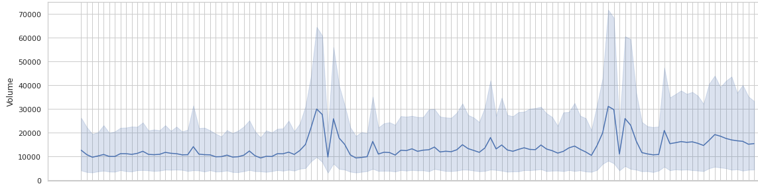

We can clearly see seasonal changes. It is also possible to recognize the growing trend. However, due to lack of time we do not make this time series decomposition. We do not use time series machinery at all to answer the questions. (See file Canadapost_Boris.ipynb, cell In [46] in BG2020).

**2.3. Testing the statistical hypotheses related to strike 2018**

To answer the questions in problem settings, we use the procedure of statistical hypothesis testing. Student’s t-test was used as a temporary means. Given the non-normality of our samples, non-parametric tests, such as the Wilcoxon signed-rank test, can be used in the future.

**2.3.1.The strike influence**

In this subsection we work on the question “How much parcel business (volume) was lost because of the strike, overall and by customer group?”. To that end, we compare the sub-samples of parcel volumes of the strike period to the same period of the previous year. The strike was happening from October 22, 2018 to November 27th 2018, for 6 weeks, having week numbers 43-48. In the second sample, we took the same weeks of 2017. We could not extend the second sample to all non-strike weeks, because we need to consider the seasonal factor. Indeed, the strike happened not far from the peak of usual activity. So when we compared the strike period to all other non-strike days, the mean strike volume is even higher than the other mean activity. This motivates our choice of pre-strike weeks, described above. The null hypothesis is that means of both samples do not differ. The alternative hypothesis is that during the strike we have lower volume of parcels than before. The test results are as follows.

For **all** customers, the mean volume during the strike is 16,814. The mean volume in the matching period before the strike is 17,057. So we can see reduction of activity. The p-value of the one-tailed test is 0.48. So the difference is insignificant. Below we can see histograms for both overall samples.

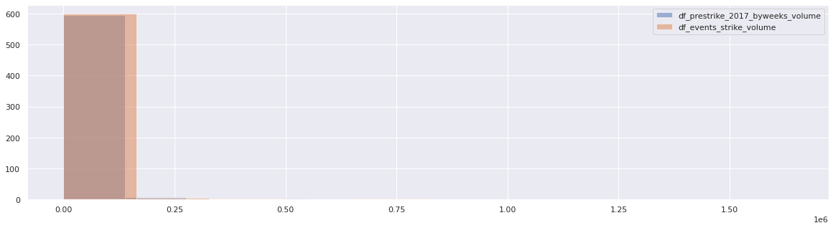

Now we need to investigate the same by groups. In the **small** group, the mean volume during the strike is 55. The mean volume in the matching period before the strike is 75. So we can see reduction of activity. The p-value of the one-tailed test is 0.002. So the difference is significant. According to context given by problem setting, small customers could remain under-served or switch to the competitor shipping providers. Below we can see histograms for strike versus the corresponding pre-strike period within the small group.

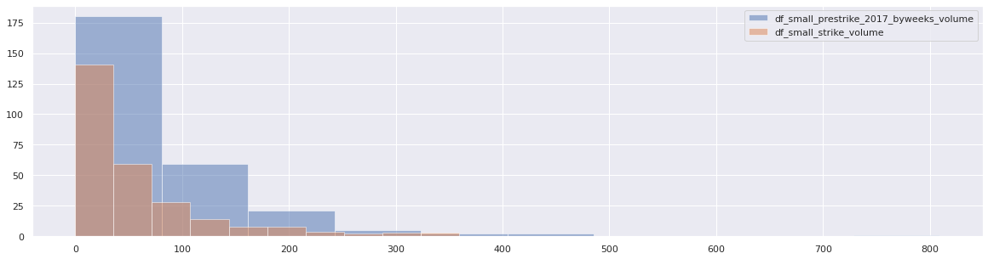

In the **medium** group,the mean volume during the strike is 817. The mean volume in the matching period before the strike is 843. So we can see reduction of activity. The p-value of the one-tailed test is 0.42. So the difference is insignificant. Below we can see histograms for strike versus the corresponding pre-strike period within the small group.

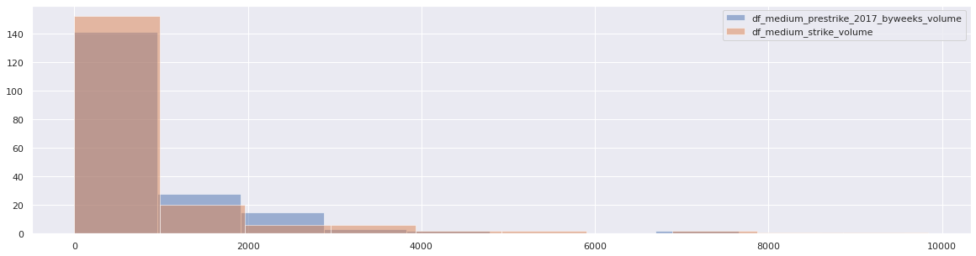

In the **large** group, the mean volume during the strike is 67,455. The mean volume in the matching period before the strike is 68,378. So we can see reduction of activity. The p-value of the one-tailed test is 0.48. So the difference is insignificant. Below we can see histograms for strike versus the corresponding pre-strike period within the small group.

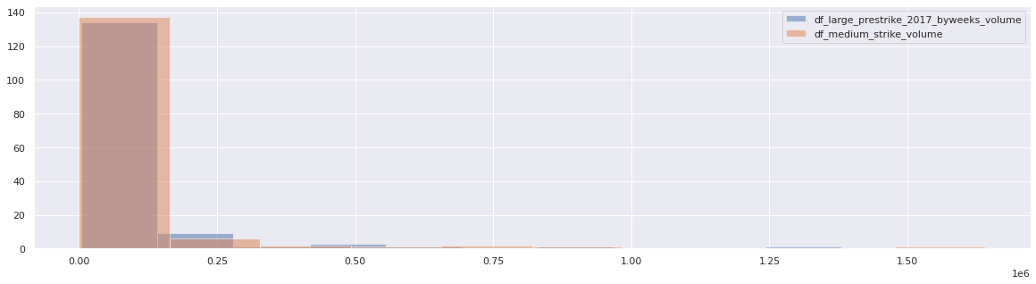

See file Canadapost_Boris.ipynb, cell In [112] - In [114] in BG2020

**2.3.2. After-strike recovery by group**

Having the spec question “Which customer group recovered the fastest and slowest?”, we need to formalize the comparison two-sample test for such recovery. We chose to compare the full post-strike period to the corresponding pre-strike period. For the post-strike we have available data for weeks 49-52 of 2018 and weeks 1-17 of 2019. This corresponds to November 27th 2018 to April 28, 2019. We compare this sample to the one of weeks 49-52 of 2017 and weeks 1-17 of 2018. The null hypothesis is that both samples have the same means. The alternative is that the after-strike period has not recovered the parcels volume or it is lower than before the strike.

Firstly, the **small** group of customers. The mean volume for the after-strike period is 75. The mean for the corresponding pre-strike period was smaller: 67. It goes to the opposite side of the alternative hypothesis, so we do not need p-value to reject it. Not only did we recover after the strike, but we exceeded the pre-strike period. This could happen due to the permanent trend of increasing remote business activity. Note that this group was the only one, significantly affected by strike. So its recovery is especially notable.

Below are histograms of prestrike vs post-strike volumes for the small group of customers.

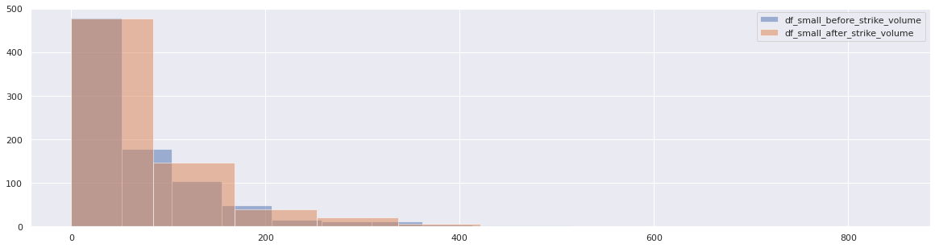

See file Canadapost_Boris.ipynb, cell **In [112] - In [114]** in BG2020

Secondly, the **medium** group of customers. The mean volume for the after-strike period is 714. The mean volume for the corresponding pre-strike period was smaller: 678. It goes to the opposite side of the alternative hypothesis, so we do not need p-value to reject it. Not only did we recover after the strike, but we exceeded the pre-strike period. The same as in the above analysis of the small group, this could happen due to the permanent trend of increasing remote business activity. Below are histograms of prestrike vs post-strike volumes for the medium group of customers.

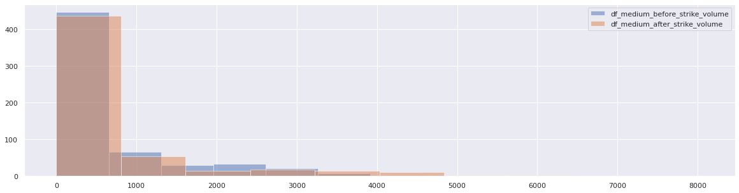

See file Canadapost_Boris.ipynb, cell **In [115] - In [117]** in BG2020

Thirdly, the **large** group of customers. The mean volume for the after-strike period is 65,986. The mean volume for the corresponding pre-strike period was smaller: 55,795. It goes to the opposite side of the alternative hypothesis, so we do not need p-value to reject it. Not only did we recover after the strike, but we exceeded the pre-strike period. As in the above analysis of the small group, this could happen due to the permanent trend of increasing remote business activity. Below are histograms of prestrike vs post-strike volumes for the large group of customers.

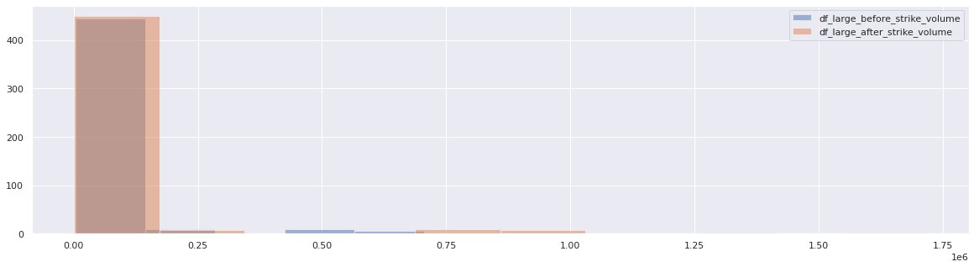

See file Canadapost_Boris.ipynb, cell **In [118] - In [120]** in BG2020

**2.3.3. After-strike recovery overall**

Having the business question “Have we fully recovered from the impact of the strike?”, now we conduct the test for overall data in the same manner as we did it above by groups. The mean volume for the after-strike period is 18,313. The mean for the corresponding pre-strike period was smaller: 13,918. It goes to the opposite side of the alternative hypothesis, so we do not need p-value to reject it. Not only did we recover after the strike, but we exceeded the pre-strike period. This could happen due to the permanent trend of increasing remote business activity.

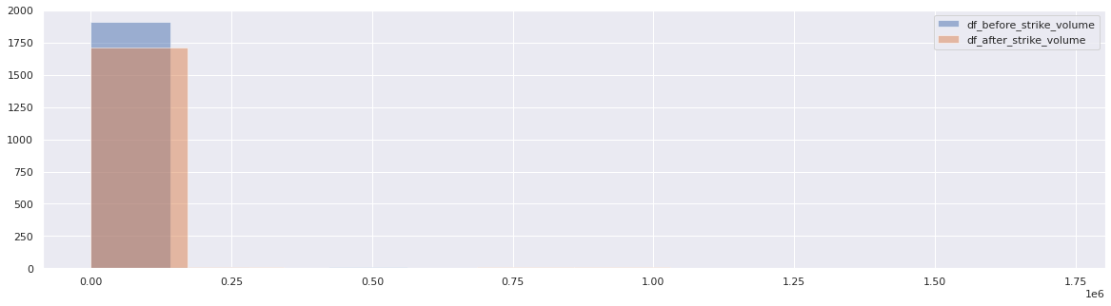

See file Canadapost_Boris.ipynb, cell **In [106] - In [108]** in BG2020

**2.3.4. Influence of media messages**

Given the question from the problem setting “Do rumours of a potential strike have an impact even before the actual strike begins?”, we investigate the period between the media announcement and actual strike. To that end, we compared it to the same period of the previous year. In the statistical test, the average overall number of parcels in the media coverage period is 14,808. In the control group, this volume is lower: 12,284. So we can preliminarily guess that upon announcement of the strike coming up, the companies hurry up to manage sending all the items before the strike starts. However, it also may be a consequence of the trend factor that the companies send more parcels over each year. However, the two-tailed p-value is 0.79. So the found difference is insignificant anyway.

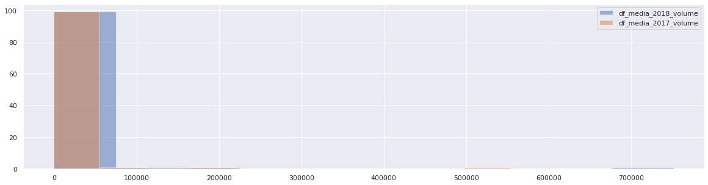

See file Canadapost_Boris.ipynb, cell **In [121] - In [125]** in BG2020

The similar result is obtained when we test the union voting event. The post-voting pre-strike period gives 12,414 of parcels on average. The corresponding period in 2017 gives 9,352. And the two-tailed p-value is 0.68, so again, upon any interpretation, the difference is insignificant.

Below are histograms of the post-voting period versus the corresponding period in 2017.

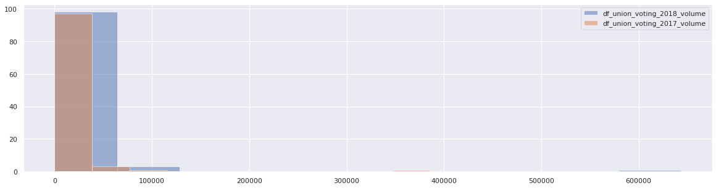

See file Canadapost_Boris.ipynb, cell In [126] - In [128] in BG2020

1. **CONCLUSION**

The test and visualization results could be summarized in the following list:

1. The volume of parcels has evident seasonal component, and likely a growing trend.
2. The strike reduced the volume of parcels compared to the pre-strike period. However, only for the group of small customers was that reduction significant.
3. The influence of media announcements of strike is indecisive. The average number of parcels increased compared to the corresponding period of 2017. However, this change is statistically insignificant. This could be attributed either to reaction of corporations to manage more shipping before the strike, or positive trend, or just random statistical deviations.
4. Contrary to expectation, we observed over-recovery of parcel volume in the post-strike period compared to the same weeks of 2017. However, this could be attributed to the growing trend.

Given additional time and resources, the following directions of further analysis could improve the results’ quality:

1. Given the positive skewness of volume distribution, it is safer to change t-tests to non-parametric tests such as Wilcoxon’s tank test.
2. It is more appropriate to model the data as dependent, using the time series models. Particularly, tend, seasonality and residual components could be extracted. Also, basic tests could be changed to break-point analysis.

**References**

1. Boris Garbuzov (2020) Git repository of the CanadaPost project. URL: “<https://github.com/borisgarbuzov/Canadapost>” [BG2020]